**Independent Arts Foundation**

**Dido and Aeneas Report**

This last October 7 – 9 we enjoyed the performances of Purcell’s beautiful opera Dido and Aeneas in the Old Queens Theatre and we are so incredibly grateful to the support of the Independent Arts foundation in helping to make the project possible.

The production was co-produced by Ensemble Galante and Mopoke Theatre Productions. Ensemble Galante is a network of performers on period instruments dedicated to bringing audiences dynamic and informed performances of music from the past. The group focuses on music from the High Baroque, Galante, and Early Classical styles of the 18th Century. Mopoke Theatre Productions aims to create exciting and enjoyable theatre and musical works as well as developing professional skills of performing artists. With their combined forces they presented a fully staged performance of Dido and Aeneas in a gritty, almost post-apocalyptic setting. They made the most of characteristic Queens Theatre with just an old van and a trailer as the set where the audience were seated in the round and the action moving in and around them. Through the music, the orchestra narrated the piece by creating a musical atmosphere as the audience arrived into the performance space and physically moved around as a part of the action during the opera performance, delivering the story up close on their baroque instruments.

The tight chorus ensemble of eight singers were costumed in run-down, tattered clothes as though time had stood still since the city of Troy burned to the ground. Dido, played by Bethany Hill, appeared as a strong military leader of Carthage and Belinda, Karen Fitz-Gibbon, as her first in command and close friend. Aeneas, David Hidden, made the perfect love interest for Dido but their destiny was manipulated by the Sorceress, Elizabeth Campbell, appearing as a glamorous Goddess in the pursuit of mischief and tragedy.

The beautiful music rang out well in the Queens’ acoustic. The audience were moved to tears and genuinely enjoyed the fresh approach to this classic piece. Thank you again to the Independent Arts Foundation.

“The production, staging, imaginative touches and interaction of the musicians with the singers was extremely well planned and executed. Congratulations to director Nicholas Cannon and also his backstage team. This afternoon’s performance was a highlight of my concert going this year! If you missed it, it is your loss.” Gabrielle Scherrer – 5MBS Radio.

“The playing was excellent under the leadership of well-known Baroque violinist Ben Dollman….. it was a delight to hear such a range of fresh young voices.” Sandra Bowdler – bachtrack

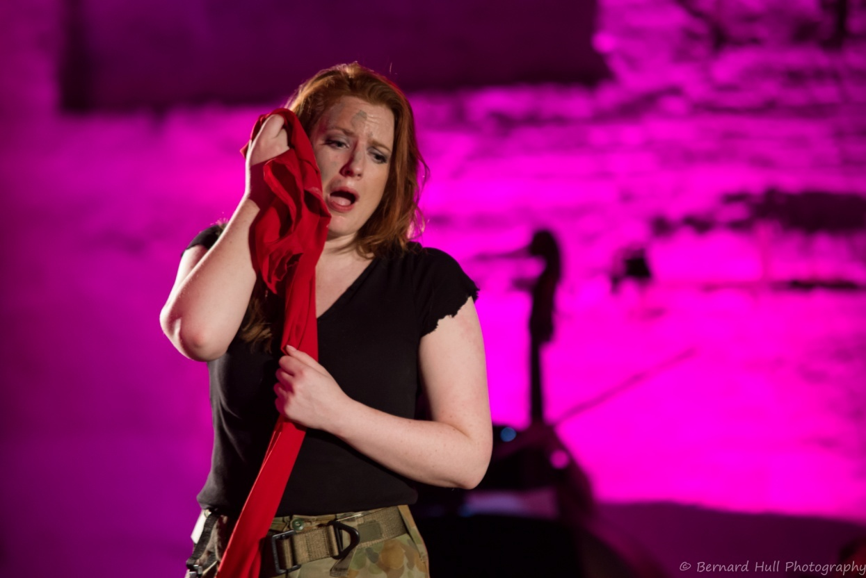 Bethany Hill as Dido. Bernard Hull – photographer