**Regional Australia Tour 2016 - Geordie Little**

In October 2016, with the help of a $1,000 grant from the IAF, I was lucky enough to embark on a small rural tour between Adelaide and Byron Bay. As I have spent much of my professional career touring around Europe, heading into small towns in my home country was something I’ve been wanting to do for a long time. Thanks to the IAF I was able to finally do it, and it was even better than I’d ever expected.

I kicked it off with a hometown gig in Adelaide at the Nexus Arts Centre, with local busker and Chapman Stick pioneer Andy Salvanos in support.   
We then hit the road (my wife along for the ride), heading up through the Clare Valley and on to Broken Hill and across to Dubbo, where I had a gig at a music hotel/shop. They got a big crowd out and a lot of the local musicians were along to support the scene which was fantastic. We met a lot of really great people and gave away a few vinyls to be played at their weekly DJ sessions!

The next stop, undoubtedly the highlight, was Nymboida, a tiny town of just a few houses, a CFS shed, and a town hall, where they had organised a regional fundraiser for a Cambodia project around my visit. They filled the town hall with people, got a few local musicians to open up, and then I played a set to one of the most appreciative crowds I’ve ever seen. It was one of my favourite gigs I’ve played, and was really the reason I wanted to hit only very small towns on the tour. The locals were thankful that they didn’t have to travel and pay hundreds of dollars to see quality music, and were open, warm, and friendly just as most small communities are. It was amazing.

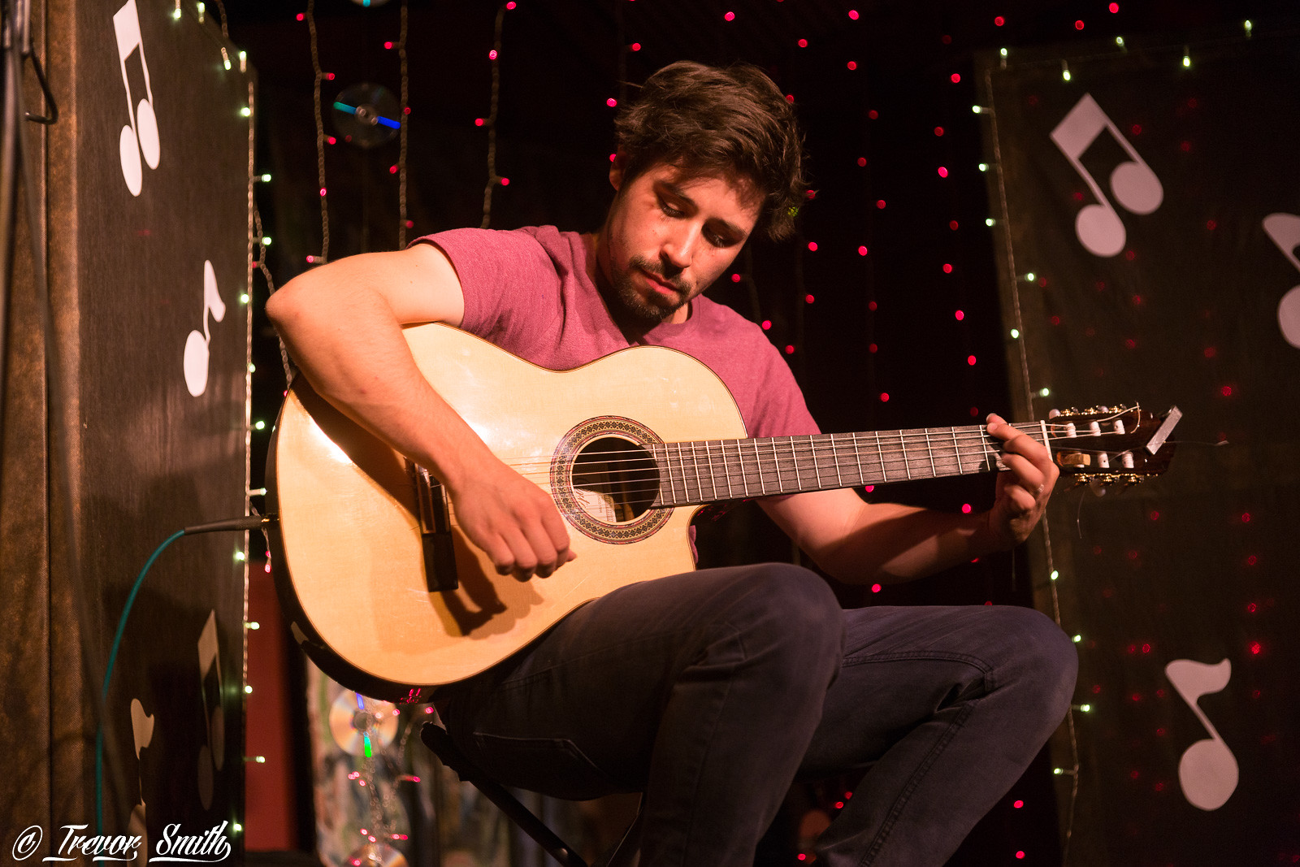

*Nymboida Town Hall*

From there it was north to play at a Wedding in Byron Bay, and then back down to Armidale for a living room concert of sorts, in a backyard music school. Again, the local musicians came out to support and again we met some amazing people.

The last stop on my short tour was then back up in Inverell, where I had the pleasure of running a 2 hour composition workshop with 2 of the local high schools. The students were all working on their own compositions and I got to share some of my story and my own techniques with them, before playing a proper concert to some of the locals that night.

Over all it was an amazing week or so, travelling around this beautiful country meeting some incredible people. It was an honour to play to people who don’t often get to see ‘international’ artists, and it made me want to do it all again in the near future.

Thank you so much to the IAF for their support, as without it I would never have been able to enjoy this experience.