The funds received from IAF have been a tremendous help over my year in 2017. Not only have the funds helped to enrich my experience of the ultimate year of my personal acting training at the Adelaide College of the Arts, but have helped to kick-start the momentum of a new theatre company for acting graduates.

Approaching my third and final year of training at AC Arts was always going to be a scary, hands-on, tiring, rewarding process. Over the year, and as part of the course curriculum, I had the opportunity to act in four different theatre productions – William Shakespeare’s *Twelfth Night,* Georg Buchner’s *Woyzeck*, Thornton Wilder’s *The Skin of our Teeth* and a group-written and devised piece *Frayed.*

Each of these intricate and complex plays require deep research and understanding before even beginning to think about getting them on their feet. As such, research materials are fundamental in getting under the skin of each play. With there only being so much material offered at TAFE Library, other sources needed to be found and indulged in elsewhere. IAF helped to secure these materials and further richen the research for each production. Such materials included academic essays and books, subscriptions to ausplays.org, Stan and Netflix.

A highlight from my training this year was an extremely positive theatre review from ex-head of drama at NIDA, Tony Knight on *The Skin of our Teeth* who trained the likes of Cate Blanchett, Miranda Otto and Sam Worthington.

He writes, “For the entire 2.5hrs, I sat transfixed and amazed, by the play, the production, and the performances. I don't usually hang around after a show, but I did tonight as I wanted to congratulate this group of Acting students on this truly wonderful production and their terrific high standard of achievement.”

The IAF grant also helped to fund the very successful premiere season of the Cabbages and Kings Collective’s Fringe show *BLINK* by Phil Porter. Cabbages and Kings is a new theatre company composed of AC Arts and Flinders acting and writing graduates and aims to provide opportunites to recent acting graduates of both courses. *BLINK* did just this, and Flinders actors Gianluca Noble and Lucy Brewer played Jonah and Sophie in its four-star reviewed season.

I had a role in media and marketing for this initial production, and managed to secure a write-up in the Advertiser as well as winning the Channel 9 Air Time competition which landed us a TVC on Channel 9 promoting the show. All of this would not have been possible without the start-up funds provided by IAF.

We plan to continue the Cabbages and Kings collective, and as a graduate actor now myself, will play a leading role in the company’s 2018 Fringe production, Duncan Graham’s *One Long Night in the land of Nod.*

To summarise, the grant from IAF has been a terrific help in both enriching the training received during my time as a student at AC Arts, as well as helping to start a new theatre company in Adelaide. But most importantly, it has put me in great stead to launch into my professional career.

Gallery

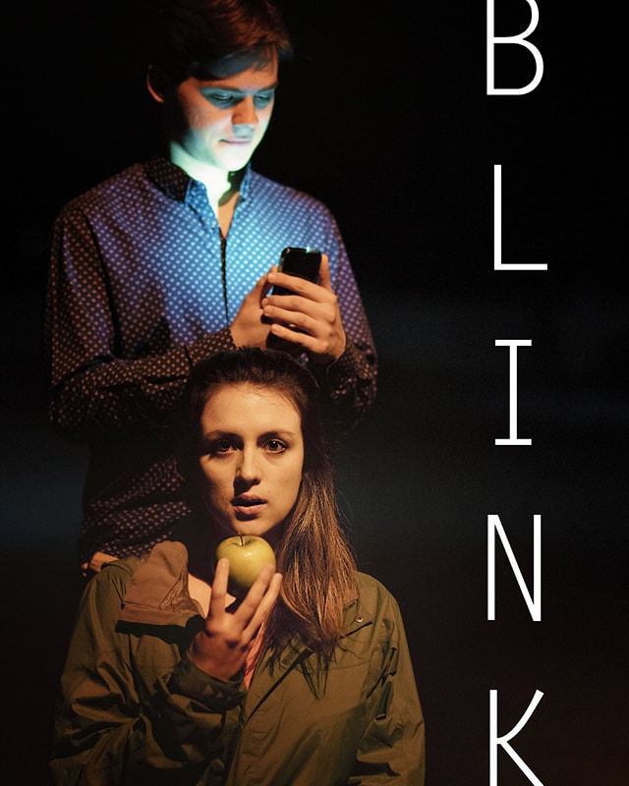

Online poster for *BLINK*

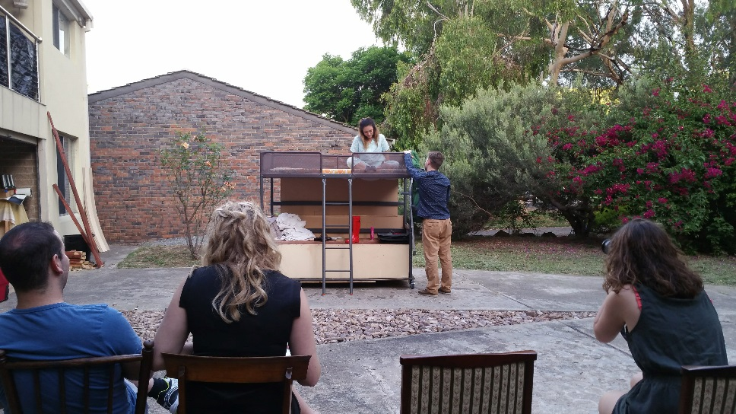

Rehearsals for *BLINK*

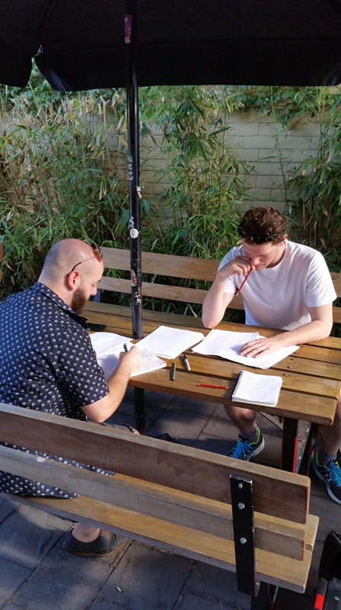

First read for *One Long Night in the Land of Nod*

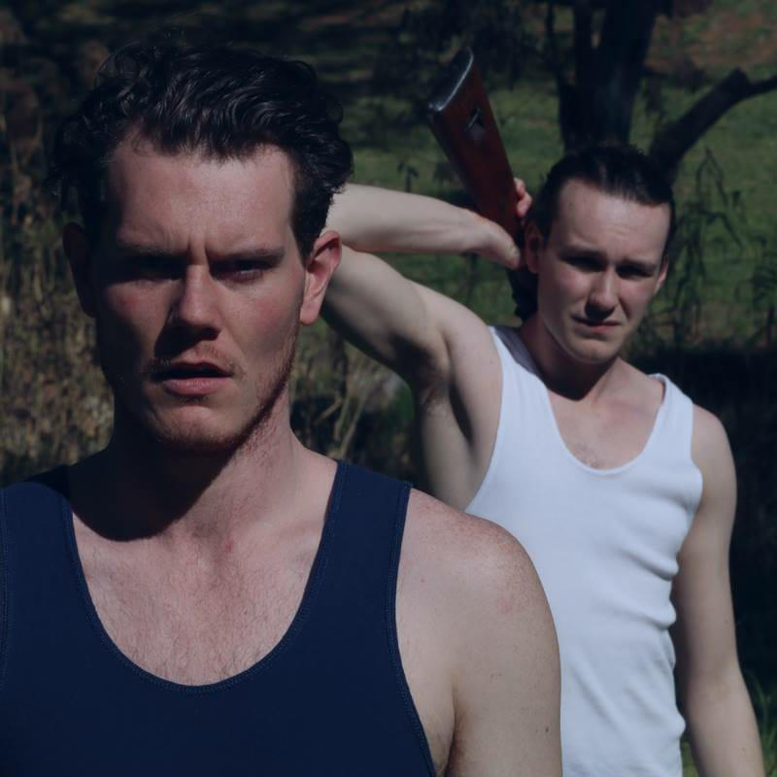

First production shot for *One Long Night in the Land of Nod*

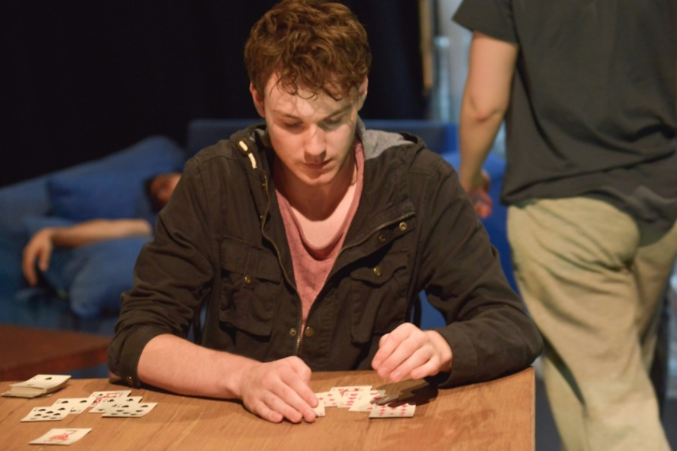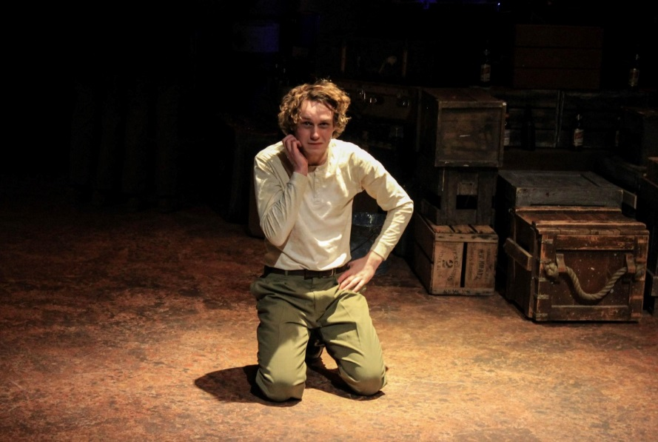

Playing Theo in *Frayed*

Playing Woyzeck in *Woyzeck*