**Independent Arts Foundation**

**Small Grants for Young or Emerging Artists Report**

Samantha Garton

I write to thank the Independent Arts Foundation for their support of Samantha Garton’s solo exhibition *Pieces of Happiness.* The exhibition took place at the Royal Adelaide Hospital as part of The Research Foundation Group Creative Health’s emerging artist program from 3 October 2022 – 7 February 2023.

*Pieces of Happiness* was Samantha’s first solo exhibition and she created over 60 artworks on paper and canvas. Samantha uses harmonious colour palettes with pops of bright colours to catch the eye and draw the viewer in. Inspired by nature and the things that make Samantha happy, *Pieces of Happiness* featured delicate motifs repeated over and over. It is through repetition that these small scale motifs become impactful and the process of mark marking enabled Samantha to fall into a rhythm and lose herself in her art.

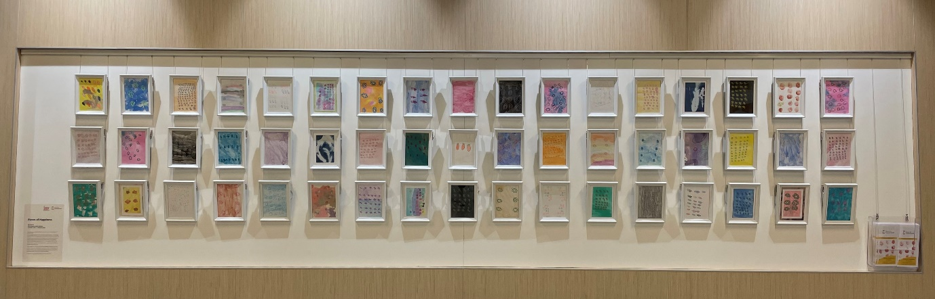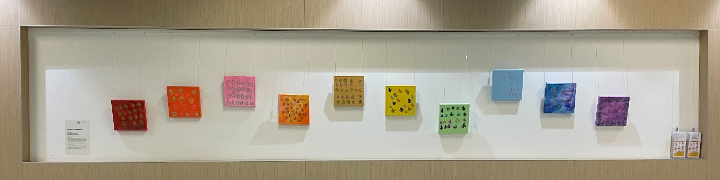

*Pieces of Happiness exhibition at the Royal Adelaide Hospital, photo courtesy of The Hospital Research Foundation Group Creative Health*

The exhibition was well received by visitors with people commenting that the work was so joyful. As Samantha herself is very familiar with hospitals she hoped her exhibition could be a joyful reprieve for hospital patients and staff alike which she certainly achieved.

*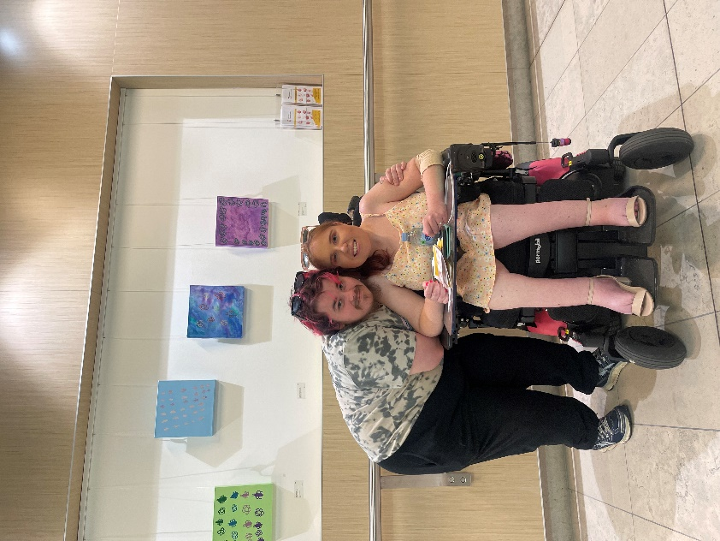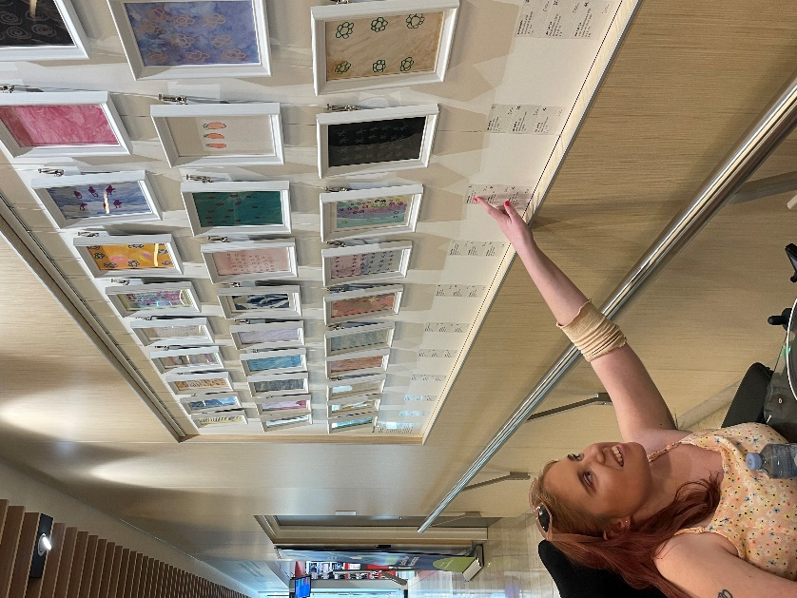‘Creating art for the exhibition was a lot of work but it was fun. I’m really proud of it all and glad people like it. My family loved it!’ – Samantha Garton*

*Left: Samantha Garton at her exhibition Pieces of Happiness, photo courtesy of the artist*

*Right: Samantha Garton and Locky Beavis at Pieces of Happiness, photo courtesy of the artist*

As Samantha’s first solo exhibition, *Pieces of Happiness,* plays a vital role in her development as an artist and represents an important milestone in her artistic career. While Tutti supports all their artists a solo exhibition is a huge undertaking and cannot be done without additional funding. The IAF grant was essential in allowing Samantha to pursue the opportunity to have a solo exhibition and present a cohesive, professional body of work.

*‘Thank you for the grant and supporting me to be an artist.’ – Samantha Garton*

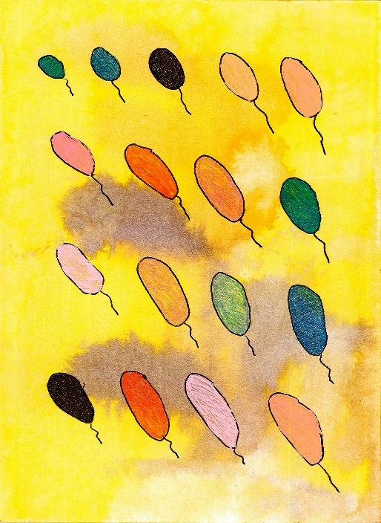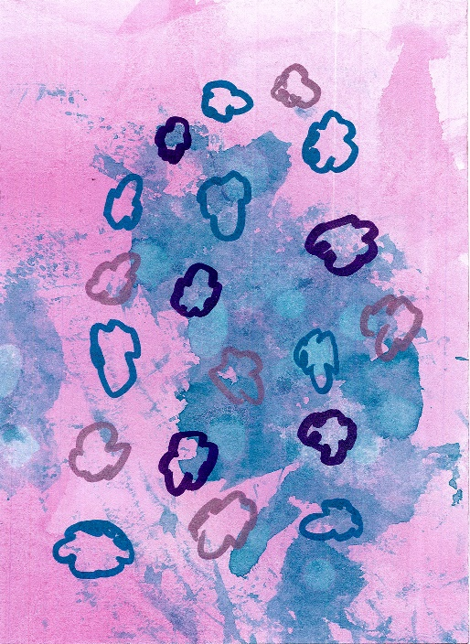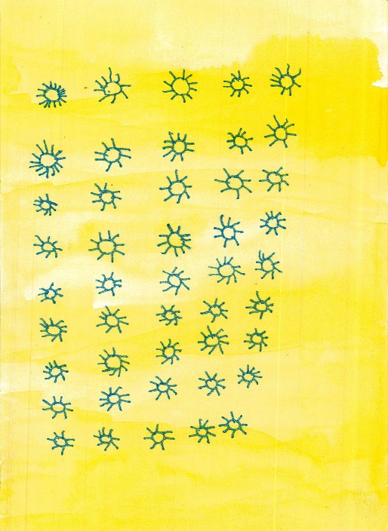

*Left: Sunny Day, 2022, pen and ink on paper, 130mm x 180mm, photo courtesy of Tutti Arts*

*Middle: Happy Clouds, 2022, marker and ink on paper, 130mm x 180mm, photo courtesy of Tutti Arts*

*Right: Rainbow Balloons, 2022, pen and ink on paper, 130mm x 180mm, photo courtesy of Tutti Arts*

The IAF grant assisted with covering the cost of materials and frames for the artworks as well having the works professionally documented and an artist fee for Samantha. Once again I’d like to express our sincerest thanks to the Independent Arts Foundation for their support of Samantha and her exhibition.

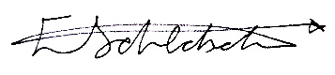Warmest regards,

Ellen Schlobohm

Exhibition curator and Tutti Arts Worker