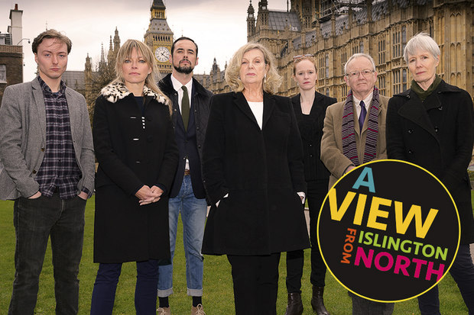

**Out of Joint**

I’ve been aware of Max Stafford–Clark and his company, Out of Joint since my days at drama school.

Mark Ravenhill, the wunderkind of the so-called ‘in-yer-face’ new writing movement of the late 1980s-early 1990s, shook up the establishment with his play “Shopping and Fucking” – an alarmingly prescient exploration of consumerism and our obsession with the self. It is also a vivid depiction Thatcher’s “there’s no such thing as society”.

Behind the play, working alongside Ravenhill, was the director of “Shopping and Fucking”,Max Stafford-Clark. Always a bastion of new writing, Max was the Royal Court’s longest serving Artistic Director, from 1979 to 1993 and was responsible for launching the career of some of the UK’s leading playwrights.He is renowned for his rigorous and unflinching method of working with new plays and for how that method is used to translatenew work to the stage.

As a director I primarily focused on contemporary theatre and with a penchant for new writing from the UK, working with Max has always been on my bucket list.In 2010 I’d seen “The Big Fellah” by Richard Bean at the Lyric Hammersmith Theatre in London, directed by Max; a wonderfully claustrophobic new play about the IRA in New York. The play was precisely directed, tighter than a drum and gripping from start to finish.

So when I found myself with a gap in my calendar, I remembered the bucket list and of my desire to work with Max Stafford-Clark. It was surprisingly easy to get in touch with Max. So few Artistic Directors of theatre companies are that accessible. But Max replied to my email within 24 hours and our conversations about how, why and when began.

Within a few months, I was in London, somewhat jetlagged, but very much charged by the prospect of working with this great director. Max is in his mid-70s now. In 2006 he suffered a major stroke and there were predictions that it would be the end of Max and his directing career. Little did they know! Despite some physical limitations and a mild slurring of the words, Max is as sharp as a tack. His wit is as quick as ever. His ability to recall a memory or moment isas clear and detailed as if it was yesterday and his attack on the work at hand remains unrelenting.

In my negotiations with Max it was agreed I would come over to be co-Associate Director on ‘A View from Islington North’. The production consisted of 5 new short plays, political satires, written by some of the UK’s leading playwrights. With new writing by the likes of David Hare, Mark Ravenhill and Caryl Churchill who could say no to such an opportunity? The plays were written in response to current events, with Brexit, the UK Labor Party leadership battle and war in the Middle East leading the evening’s proceedings.

Working with Max is a bit like being in a dodgem car. You can turn the wheel but the direction you go is out of your hands. Like any director of his lineage and experience he was always a good few steps ahead of everyone. Wearing your running shoes was always advisable!

Max works by applying actions to every line in the play, even before the actors get on their feet. An action, or transitive verb, encapsulates what the character is doing on every line and Max usually actions the entire play before he steps into the room on day one. For some actors it’s a frustrating process that robs them of their agency in making choices based on their impulses. For others, it is liberating because all they then need to do is get onto their feet and do it. On face value it seems an inflexible process that does indeed withhold creative input from the very people charged with the responsibility of bringing the text to life on stage. But Max is very open to offers and would often say “I like your offer better. Let’s use that”.

The benefits of such a process are that you can get into refining the acting much quicker. Pre-actioning a text means you are effectively getting a head start on the blocking and characterization. For my money, it’s limitations out way it’s benefits. It’s a more technical and less organic approach to working and a process that I would argue best suited to a director with Max’s extensive experience and confidence in his craft. And while I say it robs actors of their agency, it can also be argued they are then free to focus on the thing they do well – acting. But is script analysis and working with that analysis on the rehearsal room floor mutually exclusive? I am not sure they are.

I came away from my time with Max and his company enriched. Enriched because I was blessed with the opportunity of working with one of the greats from 20th Century UK theatre. Enriched because I was able to learn new ways of working that, while not necessarily gelling with my own process, will be added to my Director’s tool kit. Enriched for having the chance of working with some of the UK’s leading playwrights and enriched for having had the opportunity to broaden my experience and skills as an artist; skills that I have brought home with me to be applied to my work here in Australia.

Max is without a doubt one of a kind! He is a passionate, fearless, fiercely intelligent man who is a deep thinker and unashamedly political. He is a wonderful raconteur who loves to tell a story or two (or three). He loves theatre and he loves playwrights. A man after my own heart! And while many think he may be past his prime, I know first-hand that he still has an enormous amount to contribute to new writing and to theatre in general.

My thanks to IAF for their contribution to my trip to the UK. My time in London was made just that bit easier to manage because of the support I received from the IAF! Director – Corey McMahon below.

